

OOP Lab-02 Tasks

Name: Syed Muhammad Raza Ali

Enrolment: 02-134231-028

Course: DLD Lab

Faculty: Miss Hafsa Munawar

Exercise 1 *(Mosque.java)*

Write a program that prints a mosque, similar to the following:

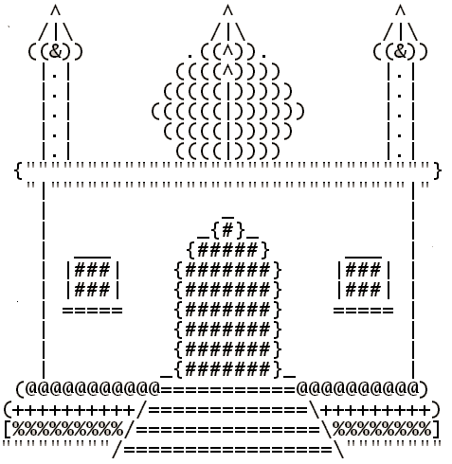

Code:

package com.mycompany.mavenproject1;

public class Mavenproject1 {

public static void main(String[] args) {

System.out.println(" ^ ^ ^ ");

System.out.println(" //|\\ //|\\ //|\\ ");

System.out.println(" (((&))) .(((^))). (((&))) ");

System.out.println(" |.| |.| |.| ");

System.out.println(" |.| |.| |.| ");

System.out.println(" |.| |.| |.| ");

System.out.println(" |.| |.| |.| ");

System.out.println(" |.| |.| |.| ");

System.out.println(" {'''''''''''''''''''''''''''''''''''''''} ");

System.out.println(" '||'''''''''''''''''''''''''''''''''||' ");

System.out.println(" || || ");

System.out.println(" || _ || ");

System.out.println(" || {#} || ");

System.out.println(" || {#####} || ");

System.out.println(" || {#######} || ");

System.out.println(" || {#######} || ");

System.out.println(" || {#######} || ");

System.out.println(" || {#######} || ");

System.out.println(" || {#######} || ");

System.out.println(" (@@@@@@@@@@@@@@===========@@@@@@@@@@@@@@) ");

System.out.println("(++++++++++++//=============\\+++++++++++) ");

System.out.println("[%%%%%%%%%%%//===============\\%%%%%%%%%%%]");

System.out.println("'''''''''''//=================\\'''''''''''");

System.out.println(" //===================\\ ");

}

}

Output:

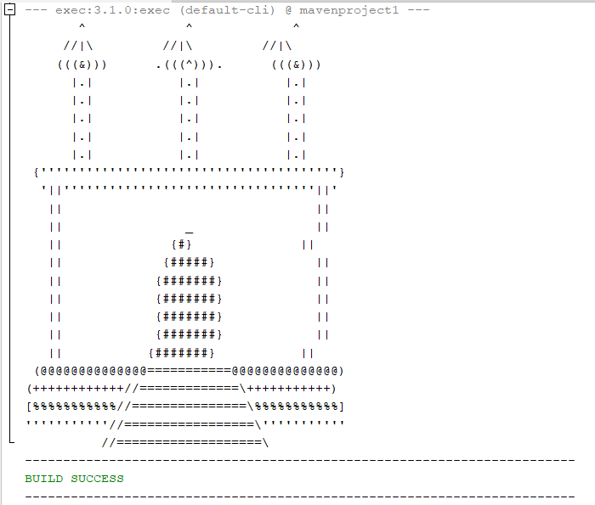

**Exercise 2 (Equations.java)**

Wrtite a java program that calculates the following equation. Where x = 6, y = 20, z=13

* 2x2  + y2
* 3x + y -3z2
* 2x -2y + 5z2

Code:

package javaapplication15;

import java.util.Scanner;

public class JavaApplication15 {

static int equation1(int x, int y){

return (2*(x*x) + (y*y));

}

static int equation2(int x,int y,int z){

return (3*x + y -3*(z*z));

}

static int equation3(int x,int y,int z){

return (2*x -2*y + 5*(z*z));

}

public static void main(String[] args) {

Scanner input = new Scanner(System.in);

System.out.println("Enter the value of x: ");

int x = input.nextInt();

System.out.println("Enter the value of y: ");

int y = input.nextInt();

System.out.println("Enter the value of z: ");

int z = input.nextInt();

System.out.println(equation1(x,y));

System.out.println(equation2(x,y,z));

System.out.println(equation3(x,y,z));

}

}

Output:

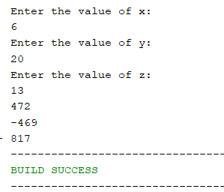

Exercise 3 *(Arithmatic.java)*

Type-in the following example, which receives the input of two integer numbers and compute the sum, difference and product. Compile and run this program.

Code:

package javaapplication15;

import java.util.Scanner;

public class JavaApplication15 {

static int sum(int a,int b){

return a+b;

}

static int sub(int a,int b){

return a-b;

}

static int mul(int a,int b){

return a*b;

}

static int div(int a,int b){

return a/b;

}

public static void main(String[] args) {

Scanner input = new Scanner(System.in);

System.out.println("Enter the value of a:");

int a = input.nextInt();

System.out.println("Enter the value of b:");

int b = input.nextInt();

System.out.println("Sum of "+a+" "+" and "+b+" is "+sum(a,b));

System.out.println("Sum of "+a+" "+" and "+b+" is "+sub(a,b));

System.out.println("Sum of "+a+" "+" and "+b+" is "+mul(a,b));

System.out.println("Sum of "+a+" "+" and "+b+" is "+div(a,b));

}

}

Output:

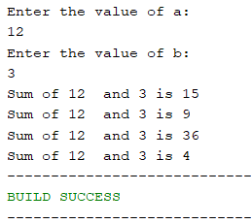

Exercise 4 *(Temperature.java)*

Celsius to Fahrenhite temperature: **F**=(**C** × 9/5) + 32

C = temperature in celsius.

F = temperature in fahrenhite

Calculate the temperature for the following degrees

* 289 **°**C
* 400 **°**C
* -36 **°**C
* -180 **°**C

Code:

package javaapplication15;

import java.util.Scanner;

public class JavaApplication15 {

static int convertTemp(int C){

int F = ((C*9/5)+32);

return F;

} public static void main(String[] args) {

Scanner temp = new Scanner(System.in);

System.out.println("Enter the temperature in Celcius");

int tempInC = temp.nextInt();

System.out.println("Temperature in Celsius = "+tempInC);

System.out.println("Temperature in Fahrenheit"+convertTemp(tempInC));

}

}

Output (for 289C):

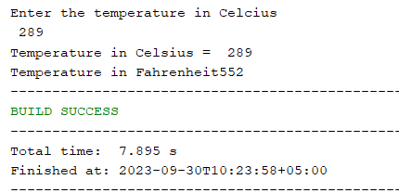

Output (for 400C):

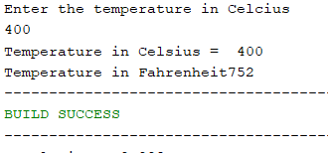

Output (for -36C):

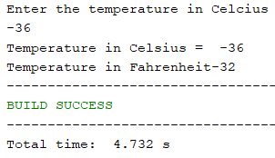

Output (for -180C):

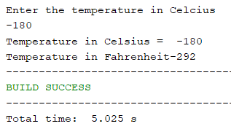

Exercise 5 *(Cookies.java)*

There are 12 cookies per box (sold at $1.14) and 24 boxes per carton. Left over boxes are sold for

57¢. Remaining cookies are given away free. Given the number of cookies produced, determine the

number of boxes, cartons, left over boxes and the total money made.

Code:

package com.mycompany.task05;

import java.util.Scanner;

public class Task05 {

public static void main(String[] args) {

Scanner sc = new Scanner (System.in);

System.out.println("Enter number of cookies produced");

int numbers = sc.nextInt();

int boxes=numbers/12;

System.out.println("no of boxes = "+boxes);

int cartons = boxes/24;

System.out.println("Number of cartoons : "+cartons);

int leftover = cartons%24;

System.out.println("Number of leftovers:"+leftover);

double totalmoney = (cartons*1.14);

double leftovermoney = (leftover * 57);

System.out.println("Totalmoney : "+totalmoney);

System.out.println("leftover : "+leftover);

System.out.println("Leftover money: " + leftovermoney);

}

}

Output:

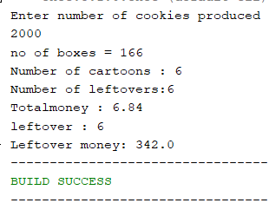

Exercise 6 *(PullyFormulas.java)*

Pulley formulas

1. calculate the speed of one pulley if there are 2 pulleys connected with a belt:

RPM2 = diameter1/diameter2 * RPM1

1. calculate the amount of weight that can be lifted with a multiple pulley system:

weight lifted = force exerted * number of up ropes

Code:

package javaapplication15;

import java.util.Scanner;

public class JavaApplication15 {

static int rpm2(int rpm1,int diameter1, int diameter2){

int rpm2 = (diameter1/diameter2 )* rpm1;

return rpm2;

}

static int weightLifted(int forceExerted, int ropes){

return forceExerted * ropes;

}

public static void main(String[] args) {

Scanner input = new Scanner(System.in);

System.out.println("Ente diameter 1 : ");

int diameter1 = input.nextInt();

System.out.println("Ente diameter 2 : ");

int diameter2 = input.nextInt();

System.out.println("Ente RPM 1 : ");

int rpm1 = input.nextInt();

System.out.println("The Speed of pulley(RPM2) = "+rpm2(rpm1,diameter1,diameter2));

System.out.println("Enter the Force Exerted : ");

int forceExerted = input.nextInt();

System.out.println("Enter the number of up ropes: ");

int ropes = input.nextInt();

System.out.println("The Amount of lifted weight = "+weightLifted(forceExerted,ropes));

}

}

Output:

